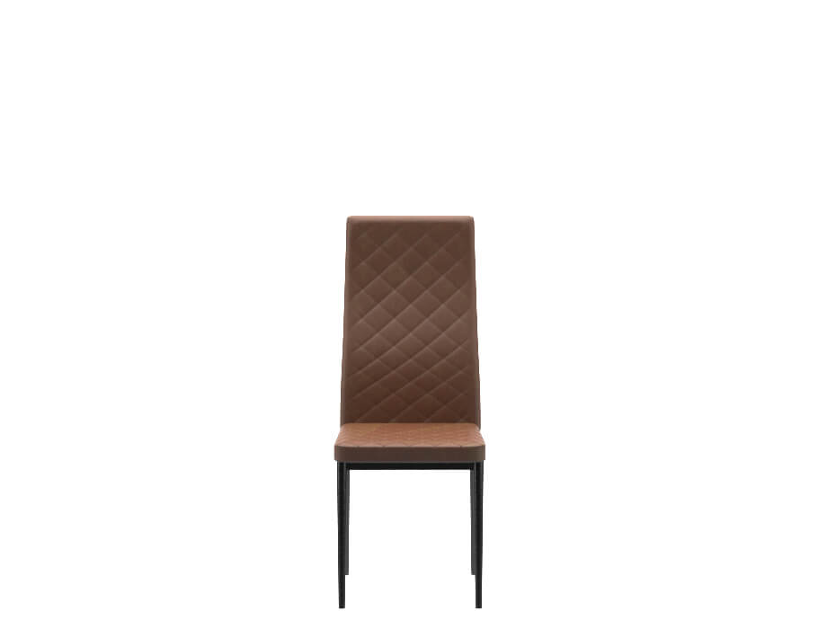

# 

Dining Chair Willa PKR 8,632PKR 10,400

Design:

[Willa](https://interwood.pk/willa-dining-set.html)

Delivered in :04 - 06 Working Days .1st

* Size:
  + 420 W x 510 D x 970 H (mm)
  + 16 W x 20 D x 38 H (Inches)
* Fully leatherette upholstered seat & Back for comfortable dining
* Metal Legs with Black Powder Coat
* The armless design gives you plenty of elbow room and allows an easy seating
* The lightweight structure makes it easy to move around
* Can be used with your study table or  extra seating  in the living along with your dining table

Note: The actual colors may vary from those shown depending on the device you are using to view the product or the angle of the item is photographed.

